Hull (watercraft)
From Wikipedia, the free encyclopedia
This article needs additional citations for verification. Please help improve this article by adding citations to reliable sources. Unsourced material may be challenged and removed. (June 2014) (Learn how and when to remove this template message)
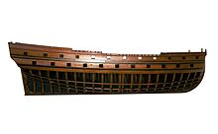
Half-hull of the 46-gun ship of the line Tigre, build from 1724 in Toulon after plans by Blaise Coulomb
The hull is the watertight body of a ship or boat. Above the hull is the superstructure and/or deckhouse, where present. The line where the hull meets the water surface is called the waterline.
The structure of the hull varies depending on the vessel type. In a typical modern steel ship, the structure consists of watertight and non-tight decks, major transverse and watertight (and also sometimes non-tight or longitudinal) members called bulkheads, intermediate members such as girders, stringers and webs, and minor members called ordinary transverse frames, frames, or longitudinals, depending on the structural arrangement. The uppermost continuous deck may be called the "upper deck", "weather deck", "spar deck", "main deck", or simply "deck". The particular name given depends on the context—the type of ship or boat, the arrangement, or even where it sails. Not all hulls are decked (for instance a dinghy).
In a typical wooden sailboat, the hull is constructed of wooden planking, supported by transverse frames (often referred to as ribs) and bulkheads, which are further tied together by longitudinal stringers or ceiling. Often but not always there is a centerline longitudinal member called a keel. In fiberglass or composite hulls, the structure may resemble wooden or steel vessels to some extent, or be of a monocoque arrangement. In many cases, composite hulls are built by sandwiching thin fiber-reinforced skins over a lightweight but reasonably rigid core of foam, balsa wood, impregnated paper honeycomb or other material.
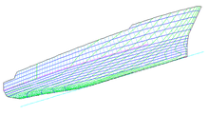
"Hull Form"

Contents
[hide]
- 1General features
- 2Hull shapes
  - 2.1Categorization
  - 2.2Most used hull forms
  - 2.3Hull forms
    - 2.3.1Chined and hard-chined hulls
    - 2.3.2Smooth curve hulls
- 3Appendages
- 4Terms
- 5Metrics
- 6History
- 7See also
- 8Notes
- 9References

General features[edit]
The shape of the hull is entirely dependent upon the needs of the design. Shapes range from a nearly perfect box in the case of scow barges, to a needle-sharp surface of revolution in the case of a racing multihull sailboat. The shape is chosen to strike a balance between cost, hydrostatic considerations (accommodation, load carrying and stability), hydrodynamics (speed, power requirements, and motion and behavior in a seaway) and special considerations for the ship's role, such as the rounded bow of an icebreaker or the flat bottom of a landing craft.

Hull shapes[edit]
Further information: Chine (boating)
Hulls come in many varieties and can have composite shape, (e.g., a fine entry forward and inverted bell shape aft), but are grouped primarily as follows:
- Chined and Hard-chined. Examples are the flat-bottom (chined), v-bottom and multi-bottom hull (hard chined).
have at least one pronounced knuckle throughout all or most of their length
- Moulded, round bilged or soft-chined. Examples are the round bilge, semi-round bilge and s-bottom hull.
defined as smooth curves

Categorization[edit]
After this they can be categorized as:
- Displacement
the hull is supported exclusively or predominantly by buoyancy. Vessels that have this type of hull travel through the water at a limited rate which is defined by the waterline length. They are often heavier than planing types, though not always.
- Planing
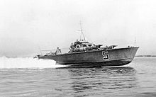
Royal Navy World War II MTBplaning at speed on calm water showing its Hard chine hull - note how most of the forepart of the boat is out of the water
the planing hull form is configured to develop positive dynamic pressure so that its draft decreases with increasing speed. The dynamic lift reduces the wetted surface and therefore also the drag. They are sometimes flat-bottomed, sometimes V-bottomed and more rarely, round-bilged. The most common form is to have at least one chine, which makes for more efficient planing and can throw spray down. Planing hulls are more efficient at higher speeds, although they still require more energy to achieve these speeds. An effective planing hull must be as light as possible with flat surfaces that are consistent with good sea keeping. Sail boats that plane must also sail efficiently in displacement mode in light winds. (see: Planing (sailing), Hull speed).
- Semi-displacement, or semi-planing
the hull form is capable of developing a moderate amount of dynamic lift, however, most of the vessel's weight is still supported through buoyancy

Most used hull forms[edit]
At present, the most widely used form is the round bilge hull.^{[1]}
The inverted bell shape of the hull, with smaller payload the waterline cross-section is less, hence the resistance is less and the speed is higher. With higher payload the outward bend provides smoother performance in waves. As such, the inverted bell shape is a popular form used with planing hulls.

Hull forms[edit]

Chined and hard-chined hulls[edit]
Further information: Chine (boating)
A chined hull consists of straight, smooth, tall, long, or short plates,timbers or sheets of ply, which are set at an angle to each other when viewed in transverse section . The traditional chined hull is a simple hull shape because it works with only straight planks bent into a curve. These boards are often bent lengthwise. Plywood chined boats made of 8' x 4' sheets have most bend along the long axis of the sheet. Only thin ply 3–6 mm can easily be shaped into a compound bend. Most home-made constructed boats are chined hull boats. Mass-produced chine powerboats are usually made of sprayed chop strand fibreglass over a wooden mold. The Cajun "pirogue" is an example of a craft with hard chines. Benefits of this type of boating activity is the low production cost and the (usually) fairly flat bottom, making the boat faster at planing. Sail boats with chined hull make use of a dagger board or keel.
Chined hulls can be divided up into 3 shapes:
- Flat-bottom chined hulls
- Multi-chined hulls
- V-bottom chined hulls. Sometimes called hard chine.
Each of these chine hulls has its own unique characteristics and use. The flat bottom hull has high initial stability but high drag. To counter the high drag hull forms are narrow and sometimes severely tapered at bow and stern. This leads to poor stability when heeled in a sail boat. This is often countered by using heavy interior ballast on sailing versions. They are best suited to sheltered inshore waters. Early racing power boats were fine forward and flat aft. This produced maximum lift and a smooth,fast ride in flat water but this hull form is easily unsettled in waves. The multi chine hull approximates a curved hull form. It has less drag than a flat bottom boat. Multi chines are more complex to build but produce a more seaworthy hull form. They are usually displacement hulls. V or arc bottom chine boats have a v shape between 6 and 23 degrees. This is called the deadrise angle. The flatter shape of a 6 degrees hull will plane with less wind or a lower horse power engine but will pound more in waves. The deep V form (between 18 and 23 degrees) is only suited to high power planing boats. They require more powerful engines to lift the boat onto the plane but give a faster smoother ride in waves. Displacement chined hulls have more wetted surface area, hence more drag, than an equivalent round hull form, for any given displacement.

Smooth curve hulls[edit]
Further information: Smooth curve hull
Smooth curve hulls are hulls which use, just like the curved hulls, a sword or an attached keel.
Semi round bilge hulls are somewhat less round. The advantage of the semi-round is that it is a nice middle between the S-bottom and chined hull. Typical examples of a semi-round bilge hull can be found in the Centaur and Laser cruising dinghies.
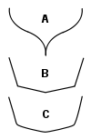
(A) S-bottom hull
compared to a
(B) hard and
(C) soft chine hull
S-bottom hulls are hulls shaped like an s . In the s-bottom, the hull runs smooth to the keel. As there are no sharp corners in the fuselage. Boats with this hull have a fixed keel, or a kielmidzwaard (literally "keel with sword"). This is a short fixed keel, with a swing keel inside. Examples of cruising dinghies that use this s-shape are the Yngling and Randmeer.

Appendages[edit]
- Control devices such as a rudder, trim tabs or stabilizing fins may be fitted.
- A keel may be fitted on a hull to increase the transverse stability, directional stability or to create lift.
- A protrusion below the waterline forward is called a bulbous bow and is fitted on some hulls to reduce the wave making resistance drag and thus increase fuel efficiency. Bulbs fitted at the stern are less common but accomplish a similar task. (see also: Naval architecture)

Terms[edit]
- Baseline is an imaginary reference line used to measure vertical distances from.
- Bow is the front part of the hull
- Amidships is the middle portion of the vessel in the fore and aft direction.
- Port is the left side of the vessel when facing the bow
- Starboard is the right side of the vessel when facing the bow
- Stern is the rear part of the hull
- Waterline is an imaginary line circumscribing the hull that matches the surface of the water when the hull is not moving.

Metrics[edit]
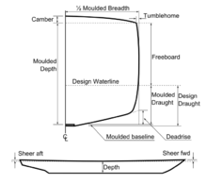
Principal hull measurements
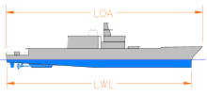
"LWL & LOA"
Hull forms are defined as follows:
- Block measures that define the principal dimensions. They are:
- Beam or breadth (B) is the width of the hull. (ex: BWL is the maximum beam at the waterline)
- Draft (d) or (T) is the vertical distance from the bottom of the keel to the waterline.
- Freeboard (FB) is depth plus the height of the keel structure minus draft.
- Length at the waterline (LWL) is the length from the forwardmost point of the waterline measured in profile to the stern-most point of the waterline.
- Length between perpendiculars (LBP or LPP) is the length of the summer load waterline from the stern post to the point where it crosses the stem. (see also p/p)
- Length overall (LOA) is the extreme length from one end to the other.
- Moulded depth (D) is the vertical distance measured from the top of the keel to the underside of the upper deck at side.^{[2]}
- Form derivatives that are calculated from the shape and the block measures. They are:
- Displacement (Δ) is the weight of water equivalent to the immersed volume of the hull.
- Longitudinal centre of buoyancy (LCB) is the longitudinal distance from a point of reference (often midships) to the centre of the displaced volume of water when the hull is not moving. Note that the longitudinal centre of gravity or centre of the weight of the vessel must align with the LCB when the hull is in equilibrium.
- Longitudinal centre of floatation (LCF) is the longitudinal distance from a point of reference (often midships) to the centre of the area of waterplane when the hull is not moving. This can be visualized as being the area defined by the water's surface and the hull.
- Vertical centre of buoyancy (VCB) is the vertical distance from a point of reference (often the baseline) to the centre of the displaced volume of water when the hull is not moving.
- Volume (V or ∇) is the volume of water displaced by the hull.
- Coefficients^{[3]} help compare hull forms as well:
1) Block coefficient (C_{b}) is the volume (V) divided by the LWL x BWL x T. If you draw a box around the submerged part of the ship, it is the ratio of the box volume occupied by the ship. It gives a sense of how much of the block defined by the L_{WL}, beam (B) & draft (T) is filled by the hull. Full forms such as oil tankers will have a high C_{b} where fine shapes such as sailboats will have a low C_{b}.

2) Midship coefficient (C_{m} or C_{x}) is the cross-sectional area (A_{x}) of the slice at midships (or at the largest section for C_{x}) divided by beam x draft. It displays the ratio of the largest underwater section of the hull to a rectangle of the same overall width and depth as the underwater section of the hull. This defines the fullness of the underbody. A low C_{m} indicates a cut-away mid-section and a high C_{m} indicates a boxy section shape. Sailboats have a cut-away mid-section with low C_{x} whereas cargo vessels have a boxy section with high C_{x} to help increase the C_{b}.

3) Prismatic coefficient (C_{p}) is the volume (V) divided by L_{pp} x A_{x}. It displays the ratio of the immersed volume of the hull to a volume of a prism with equal length to the ship and cross-sectional area equal to the largest underwater section of the hull (midship section). This is used to evaluate the distribution of the volume of the underbody. A low or fine C_{p} indicates a full mid-section and fine ends, a high or full C_{p} indicates a boat with fuller ends. Planing hulls and other highspeed hulls tend towards a higher C_{p}. Efficient displacement hulls travelling at a low Froude number will tend to have a low C_{p}.

4) Waterplane coefficient (C_{w}) is the waterplane area divided by L_{pp} x B. The waterplane coefficient expresses the fullness of the waterplane, or the ratio of the waterplane area to a rectangle of the same length and width. A low C_{w} figure indicates fine ends and a high C_{w} figure indicates fuller ends. High C_{w} improves stability as well as handling behavior in rough conditions.

Note:
- Depth of cockpit (front & rear)

. | 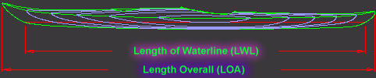
.top | 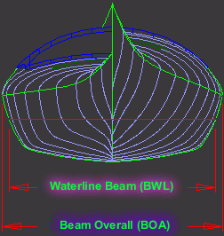  The 'horizontal' difference between the BOA and the BWL is also referred to as 'flare'. A large flare rapidly changes the position of the TCB (transversal center of buoyancy) of the kayak when leaned to the side. The TCB moves farther sideways or 'outboard', underneath the paddler's TCG (transversal center of gravity) thus providing support and resistance to capsize. This is called "secondary" or "reserve" buoyancy. A good analogy is the example of a trimaran outrigger. The farther the outrigger (buoyant volume) is from the main hull, the more resistant the craft becomes to the 'heeling moment' or force of the sail that would keel it over. That is also a main reason why sailboats are relatively 'wide' and feature large hull flare.
.top | 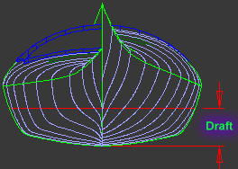  Draft is measured from baseline to the designed waterline. It is the amount that the kayak is submerged in the water.
.top | 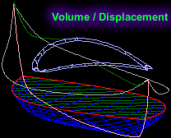  The "Volume" indicates the volume of sea water (ft^3) the kayak displaces at the designed displacement (lb). Note that sea water is denser than fresh water so even though the kayak has the same displacement (kg or lb), the volume displaced will be slightly higher in fresh water. This means that the kayak will be submerged more in fresh water. In practical terms, this is of no consequence.  Let's say the volume displaced is 4 ft^3 so the difference is about 6.8lb between fresh water and sea water displacement. This translates to about 1/8" (2mm) difference in draft.  Salt water is used for all calculations.  Sea water density - 1025,9 kg/m^3 or 64 lb/ft^3  Fresh water density - 1000 kg/m^3 or 62.3 lb/ft^3

.top | 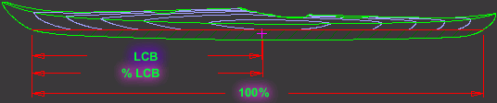  LCB is the distance from the start of the waterline to the center of the volume the kayak displaces. The center of the displaced volume is called a 'centroid' but LCB is just the x direction component of its coordinates. The others are VCB - vertical center of buoyancy and TCB - transverse center of buoyancy.  The center of buoyancy as an imaginary focus of all vertical forces that keep the kayak afloat. Its counterpart, the LCG, is the focus of all loads that push the kayak down. Under normal conditions and In the absence of other forces LCB and LCG are in balance or equilibrium.  The %LCB is the longitudinal location of the LCB with respect to the waterline. %LCB is what often distinguishes whether a kayak is 'Fish' or 'Swede' form. Fish form kayaks have LCB less than 50% of LWL while Swede hull forms are more than 50%. Swede hullforms displace water more efficiently, reducing the effect of wave resistance and are therefore faster, especially at higher cruising and racing speeds. Smaller pitching motion in waves, good handling in following seas (waves coming from the back) and drier ride are few other benefits of Swede hull forms.  All One Ocean Kayak designs are Swede hull forms.  LCB in sea kayaks ranges from 49% for 'Fish forms' up to 55% for 'Swede forms'. Designs beyond these limits result in poor directional stability as in the Swede forms or lack of maneuverability as in the Fish forms.
.top | 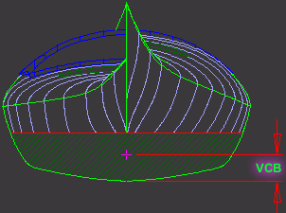  Vertical center of buoyancy (VCB) is the vertical coordinate of the displaced volume centroid. Hard chine and flat bottom boats have lower VCB than rounder or elliptical hulls. Higher VCB has positive effects on secondary stability.

.top | 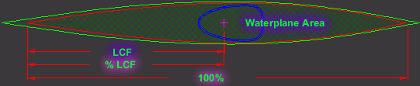  Waterplane area is the horizontal patch of surface that is formed by the intersection of the kayak hull at the designed waterline (or Draft) with the surface of the water. The Waterplane has an affect on wave resistance, stability and pitching in waves.  LCF is the longitudinal coordinate of the Waterplane Centroid from the start of the waterline.  %LCF is the longitudinal location of the Waterplane centriod with respect to the length of the waterline. The axis of the pitching motions (rocking back and forth) in a boat mostly coincides with the LCF. In general, the larger the %LCF the smaller the amplitude of pitching.
.top | 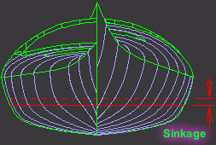  Sinkage measures the distance a kayak sinks for a given load on top of the 'displacement'. This is very useful to know when loading kayak with gear. It suggests the amount of loading before the kayak's performance is noticeably degraded.  This measurement is not linear. This means that the sinkage for a given kayak may be 92lb/inch, but it may be only 38lb per 0.5inch but 220lb per 2 inches.

.top | 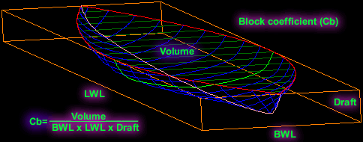  Unlike the prismatic coefficient, Cb is not constrained by the crossectional shape of the hull so it measures the fullness of the entire displaced volume rather than the 'tips' alone. If the hull filled the entire block defined by LWL x BWL x Draft, the Cb would equal 1.  Both the Cm and Cp are related to the Block coefficient in the following relationship CB=Cp x Cm. Large block coefficient makes for 'squat' hulls with poor directional stability.
.top | 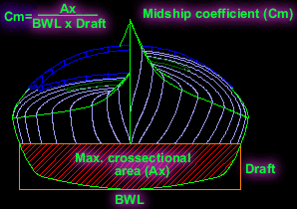  Midship coefficient is defined as the ratio of the maximum sectional area of the hull divided by the rectangular area formed by the waterline beam and draft. The larger the Cm the more rectangular and hard chined the sections. Note, that water must bypass this shape as the kayak plows its way through it and a large Cm implies more drag. Cm is a large factor in determining the shape of the hull as well as the surface area. The compromise here is between the largest Ax with the smallest perimeter and the stability of the craft. An efficient crossectional shape would have to be elliptical but this is not always desirable if a hull must perform well in ways other than pure speed. Needless to say, its all carefully balanced compromise.
.top | 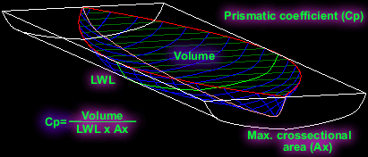  Prismatic coefficient determines the 'fatness' or 'fineness' of the hulls ends. It is the ratio of the 'displaced volume' divided by a block, the volume of which equals the length of the waterline multiplied by the hull's maximum crossectional area. The slimmer the tips of the kayak the less volume of the block the hull occupies and the smaller the Prismatic coefficient. Conversely, imagine a boat such as a barge or pontoon that would fill the entire volume of the block. In this instance the Cp would be equal to 1.  Prismatic coefficient is one of the more important factors used in determining the general shape of the hull for a given performance envelope. There is a direct correlation between Prismatic coefficient, hull speed and waterline length as relates to wave resistance. Cp is incorporated into most 'Hull performance' prediction algorithms and is also used by hull designers to shape their boats for optimal performance within the desired speed range.  Cp's for kayaks range from 0.45 for lower speed hulls up to 0.65 for racing kayaks.
.top | 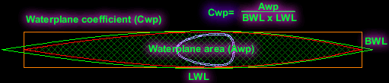  Like the Cm, the Waterplane coefficient expresses the fullness of the waterplane. Full waterplane is an essential ingredient in a seaworthy kayak design. It improves secondary stability as well as handling behavior of the kayak in rough conditions.

.top | 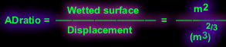  Area / Displacement Ratio  This ratio is one of the true measurements of the wetted surface area as it relates to the displaced volume it contains. For example, kayak X that has a low A/D ratio can take a bigger load or fit a heavier paddler than kayak Y, even though both have the same wetted surface. Since both kayaks will have the same viscous resistance, kayak X will be more efficient because it is not penalized by the extra weight.  This ratio is useful only in conjunction with other hydrostatic indicators. For example, a sphere which has the lowest A / D ratio of all solid objects, would hardly make a suitable craft.  Kayak A/D ratios range from 8.1 for fast round hulls to about 9.4 for hard chined, flat bottom 'dragsters'.  The ratio has no units because they cancel out.
.top | Length / Beam Ratio  This ratio is the LWL divided by BWL and is a generally good predictor of kayak performance. The range goes from about 5 for very short recreational kayaks to more than 14 for high performance sprint kayaks. The higher the ratio the higher the potential speed because of reduced wave resistance.
.top | 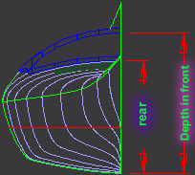  Both the front and rear depth measurements of the cockpit are essential for proper matching of the kayak to the size and paddling style of the kayaker. The measurements apply to the usable inside cockpit.

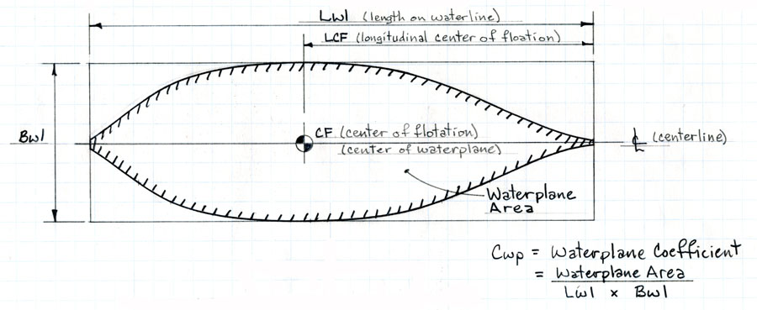
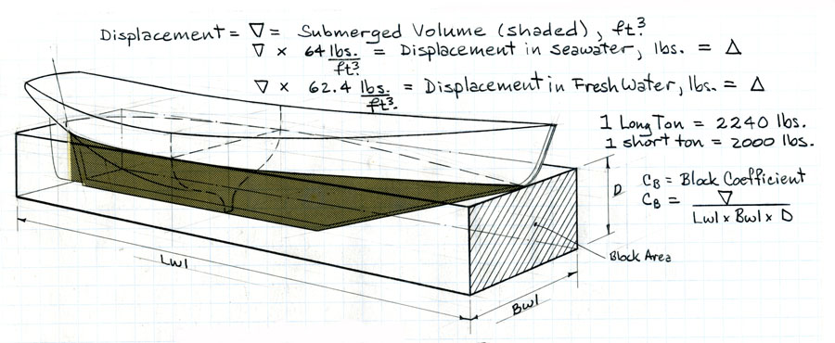

STABILITY DISCUSSION
- Back

Introduction
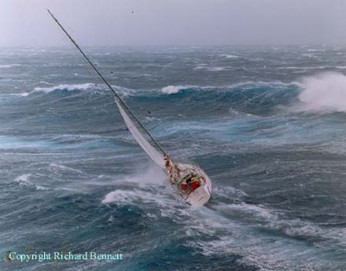
This outline on stability is based on "The Safety of Small Commercial Sailing Vessels" A Code of Practice, which emphasises the point of vanishing stability as THE MAJOR INDICATOR of a yachts ability to resist capsize. We are not attempting to address other issues relating to stability in this section.
The 1998 Sydney-Hobart Yacht Race gave a very clear example of weather conditions, where the stability of a yacht becomes an issue. These photos show one of my designs in these severe conditions and the large breaking waves associated with this storm.
The yacht "Aspect Computing" is 16m L.O.A. (54ft) with a 3m draft (9'10") lifting bulb keel and a point of vanishing stability of approximately 140deg.
"Aspect Computing" sailed through the storm and finished the race taking first in Division 1 Performance Handicap. Photos: copyright Richard Bennett.
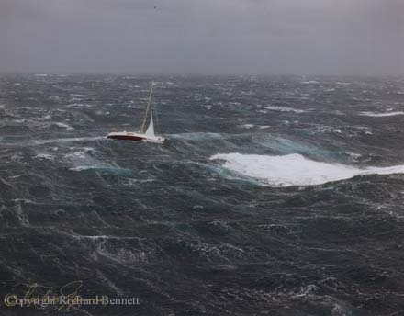

U.K. Code of Practice
"The Safety of Small Commercial Sailing Vessels" A Code of Practice (referred to as the Code of Practice in this discussion) is based on work undertaken by the Wolfson Unit and sponsored by the U.K. Department of Transport, to develop stability criteria appropriate for the safe operation of sailing vessels. Much of the research was undertaken so that the master of a sailing vessel could measure his vulnerablity to downflooding in gusts and downflooding in squalls based on a calculated maximum steady heel angle, which we will not go into here.
Part of the research and subsequent code specifies a minimum range of stablity for a given size of yacht and a method of estimating the range of stability for yachts under 15m. The research undertaken at the Wolfson Unit indicates ... "that the most important characteristic for survival of a breaking wave capsize is a large range of stability, since vessels with low ranges are prone to remaining inverted following such an incident. Furthermore, the vessels most vulnerable to such a capsize are wide, shallow, light hulls, and these characteristics normally go hand in hand with a relatively low range of stability. It is likely therefore, that a vessel with a low range will be more likely to capsize and less likely to self-right than one with a large range of stability. A high roll inertia is of benefit in reducing capsize vulnerability but is difficult to calculate or measure and so has not been incorporated in the standards.
The larger the wave encountered, the more likely is the capsize, so smaller vessels have a higher probability of capsize. To maintain a more even probability of capsize the standards require a greater range of stability for smaller yachts" ... - From paper by B.Deakin B.Sc.,C.Eng - given to The Royal Institution of Naval Architects.
The following list shows the minimum range of stability required for a given size of yacht between 9 and 23m and clearly shows the smaller the yacht, the higher the angle required. The figures for Category 0 are those applicable to offshore cruising yachts.
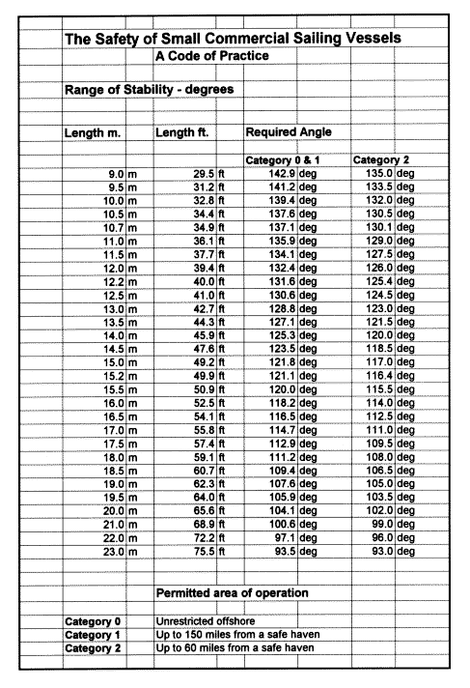

Formulae for Estimating Range of Stability for Vessels less than 15m (50ft) in Length
The range of positive stability for a vessel fitted with an external ballast keel may be estimated from the following formulae:
Estimated Range = | 110 + ( 400 / ( SV - 10.0 ) )
SV = | Beam^2 / ( BR x DCB x (Displaced Vol )^1/3 )
BEAM = | Greatest Beam Measured (excluding rubbing strips) - in Metres
Ballast Ratio (BR) = | Weight of Ballast in Tonnes contained in the Keel, divided by the Full Displacement in Tonnes
Displacement Volume = | The Volume of a Vessel's Displacement in cubic metres, at the Operational Draft
Draft of Canoe Body (DCB) = | In Metres, is taken by measuring the Maximum Draft at the 1/8 of the Full Beam from the Centreline in way of the Transverse Section at Greatest Beam

Using the R415 as an Example
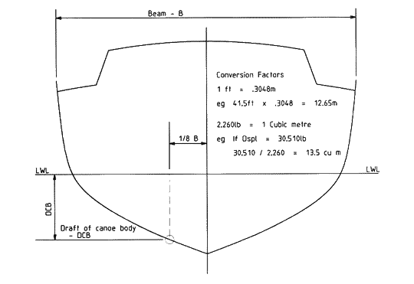

Further Requirements
If a vessel under 15m (50ft) is fitted with more than one of the following:
- Roller Furling Headsail
- In-Mast or Behind-Mast Roller Furling Mainsail
- A Radar Antenna mounted higher than 30% of the length of the vessel above the waterline
then the Code of Practice requires that ... the centre of gravity of a vessel should be established by an inclination experiment and, in addition, a curve of static stability (GZ Curve) for the loaded departure, 100% consumables, should be produced.
The above formulae for estimating the range of positive stability should be treated as an "estimate only" as it is possible to have yachts which do not meet the minimum required standard for range of stability, based in the formulae used, but comfortably meet the minimum standards when an inclination experiment is conducted.
An example of this is the R12.2m - DSN#26, which, using the formulae, has an estimated range of stability of 118-120 deg, but when the VCG is established using an inclination experiment then the range of stability is approximately 139-150deg, depending on loadings - see example curves below.

Range of Positive Stability - GZ Curve
The following 2 stability curves of the R12.2m DSN#26 "Red Jacket" give examples of the variations in righting arms and points of vanishing stability (PVS) which can occur with different vertical centres of gravity (VCG).
This lift bulb keel racing yacht had an inclination experiment conducted, with the yacht in measured condition i.e. no loading, and the VCG of the yacht was established. The first curve shows the yacht with keel fully down in its unloaded condition. The bulb keel arrangement gives a very low VCG for the ballast.
The second curve shows the yacht loaded with all of the crew weight and gear weight for racing located at deck HEIGHT and on centre line. The PVS is still 139.2 deg with keel fully down.
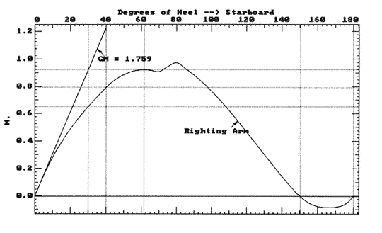 | 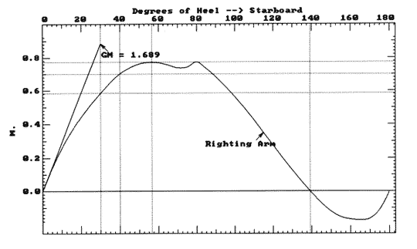
2.8m lifting bulb keel - VCG 256mm below DWL - PVS 150.2 deg - In measured lightship condition | 2.8m lifting bulb keel - VCG 60mm below DWL - PVS 139.2 deg - All crew weight and gear weight on deck and on centreline

BHSY - Hydrostatics Software
We use BHSY software from Creative Systems to analyse the stability of the designs, considering the changes in the vertical centre of gravity and the effect this has on the over all stability of the yachts. A complete 3D computer model of the yacht is created ... including hull, keel, rudder, deck, house and cockpit. In the design process, before a boat is even built, calculations are made to estimate the vertical centre of gravity (VCG) and then initial hydrostatics details are run to make sure the design meets a reasonable standard. Boats which have been launched can have an inclination test done to establish the vertical centre of gravity of a yacht for a known loading and a known displacement. This information is used in BHSY, in conjunction with the 3D computer model, to establish the righting arms at regular intervals between 0 and 180 deg. The maximum righting arm is established, the righting arm curve is defined, as well as the point of vanishing stability as shown in the curves above.

- Home

- Price List

- Contact Us

CEDAR STRIP CONSTRUCTION
- Photos
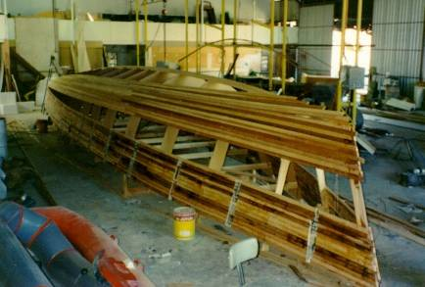
Cedar strip construction has proved to be very popular with professional and amateur boatbuilders for one-off construction because it is a quick way of establishing the shape and structure of the hull. There are a number of different design styles on the web site which use this method. They include the cruiser/racers, the performance cruising yachts and the R15.2 fast cruising yacht. All have FRP/foam sandwich decks.
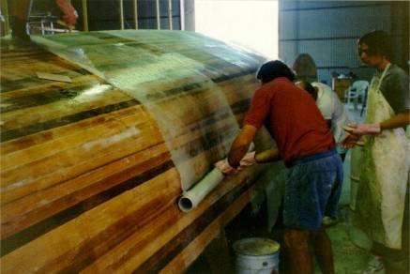
The cedar thickness varies with the displacement of the yacht and the expected loads. The smaller yachts use 20mm to 22mm cedar while yachts such as the R14.8 use 28mm cedar. The construction drawings specify a good sized laminated timber backbone - especially in way of the keel and mast step where there is extra width and nearly double thickness. Fixed and lifting keels have been used.
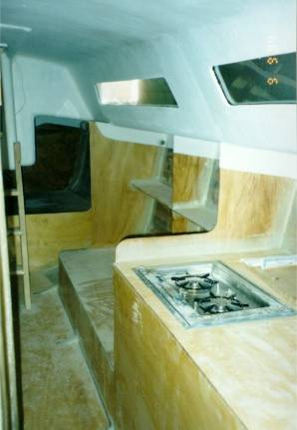
Various weights of triaxial, biaxial and double bias materials are specified for the hull, deck and internal structure. On the outside skin there is double thickness fibreglass along the centreline where the laminates overlap. To further increase the strength, extra layers of fibreglass are specified in the slamming areas forward and around the keel and chainplate knees. The extra layers are installed before the laminated timber floors, which are also heavily fibreglassed.
The accommodation forms part of the structural strength of the yacht, and combined with the laminated timber floors, foam floors, frames, stringers and bulkheads - such as the collision and watertight bulkheads - give a strong, moderate weight construction. Integral water tanks c an also be installed. Mostly, the decks are laid up on a craftwood female mould and generally use 80kg/cu m foam with higher density foam in the load areas.

Sailboat Stability and the Righting Moment
Feeling a sailboat heel under him for the first time, a novice sailor may wonder what stops it from going all the way over. The righting moment is, of course, the reason why it doesn't.
Many years ago my son James asked me just that.
"It's that lump of lead in the keel" I explained.
"Why put lead in something you expect to float?"said James.
Hmm, perhaps he was onto something - I put him down as a future multihull man...
This piece of nostalgia hints at the two key ingredients to stability - ballast and hull form.
Monohulls have more of the first and less of the second, and multihulls very little of the first and much of the second.
And stability considerations fall under two further headings - static and dynamic. Static being when the boat is at rest; dynamic when underway and subject to the forces of wind and waves.
Catamarans rely almost entirely on Form Stability

Static Stability
Take a look at the sketches below:~
Righting Moment created as the boat heels
With the boat upright, the Centre of Gravity (G) is in line with the Centre of Buoyancy (B); effectively there is no righting moment.
But as the boat heels, a righting moment develops. The Moment Arm (Z) is the horizontal distance between G and B, and the Righting Moment Gz is the product of the moment arm and the boat's displacement.
But whilst the boat's displacement and the location of its Centre of Gravity remain constant, Z changes as the boat heals more and more. There comes a point at which Z reaches a maximum value, normally at an angle of heel of around 60 degrees or so. As the boat heels past this point it decreases, leading eventually to a capsize.
The relationship between heeling angle and righting moment is different for all boats, and the plotted Gz curve gives an excellent indicator of the boat's static stability.
But the boat's static stability and its righting moment is only part of the story. How will it react to a sudden gust of wind or when clobbered by a large wave?

Dynamic Stability
There's no arguing that heavy displacement helps a boat's stability, but the most important factor affecting dynamic stability is its moment of inertia. This is the measure of the boat's resistance to angular acceleration.
The three axes of rotation
Boats rotate around three axes - rolling around the fore and aft axis; pitching about the transverse axis; yawing around the vertical axis.
It's the Roll Moment of Inertia (RMoI) that should concern us most as it's around the fore and aft axis that a boat is most likely to capsize.
This is calculated by multiplying the weight of all the boat's constituent parts by the square of the distance from the boat's Center of Gravity to the part's Center of Gravity - a tedious but necessary task for the designer. The squared term means that the distance of heavy items from the Center of Gravity greatly affect the RMoI, and the greater RMoI the less the boat will react to a gust of wind, or a large wave.
So boats with their ballast deep in their keels, their fuel and water tanks as far outboard as possible, and long heavy masts will have greater RMoI's and will be more dynamically stable as a result. Such boats will have long roll periods and will be highly resistant to rapid changes in heel angle.
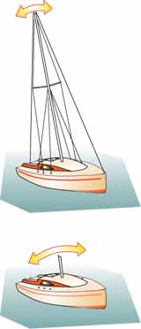Lost your rig? You'll roll much more!
This will be very apparent to a crew unfortunate enough to have lost their rig, as this item is the boat's greatest contributor to the moment of inertia. Without it, the boat's roll period will be very quick and snappy, and the probability of capsize much higher.
Makers of grandfather clocks had cause to be grateful for the effects of the rotational moment of inertia. They used it to govern the rate of gain, or loss, of their creations.
To correct a 'slow' clock, the pendulum would be shortened slightly thereby reducing the distance to the neutral axis. This decreased the period of oscillation - it would swing faster - and speed up the clock's mechanism. Conversely, for a clock that gained, the pendulum would be increased in length to create the opposite effect.
The principal reason for using pendulums in clocks was that for a given length, the period of oscillation remains constant, irrespective of the amplitude.
Artwork by Andrew Simpson
And so it is with a boat; if she's rolling gently at anchor, or from gunwale to gunwale in a seaway, the roll period will be the same.
So clearly there's a lot more to a sailboat's stability than the Righting Moment alone.

A Heavy or a Light Displacement Hull for Offshore Cruising?
In the early days of sailboat cruising, heavy displacement hull forms were the only choice for long-distance offshore cruising, solely because light materials for the hulls, spars, rigging and all the other fittings and equipment that go to make up a sailboat just weren't available.

Displacement Length Ratios:
Under 90 - Ultralight;
90 to 180 - Light;
180 to 270 - Moderate;
270 to 360 - Heavy;
360 and over - Ultraheavy;
These days, with the advent of exotic composite laminates and lightweight fittings, super-strong and ultra-light displacement hull forms are regularly seen crossing the world's oceans.
But there are plenty of sailors around that still favour the easy motion of heavy displacement hulls for offshore cruising, cheerfully conceding the extra days spent at sea for the benefit of increased comfort in rough seas.
Elsewhere on this website we've seen how displacement has a consequential influence on stability, performance and comfort. Now let's turn it around and look at the strengths and weaknesses that each one - from ultra-heavy to ultra-light displacement hull types - has to offer.

Heavy and Ultra-Heavy Displacement Hulls
With Displacement/Length ratios of 360 plus, ultra-heavy displacement hull styles have fewer devotees these days, though for passionate cruising traditionalists it's de rigueur. Heavy displacement sailboats of this type will have a full (or long) keel, which will bring with it some benefits - and some significant limitations.

In light winds, a boat of this type will sail slowly - if at all - due to the hull drag caused by its high wetted area and the power required to shift its massive weight.
It will only just be getting into its stride when other more moderate types are taking in reefs.
Apart from its contribution towards a sailboat's stability the next most important function of a keel is to resist leeway. Unfortunately, long, low aspect ratio keels aren't very good at this so they must make up in area what they lack in efficiency.
To counteract the hull drag caused by the surface area more sail area is required, so to enable the boat to stand up more ballast is needed, which is why long-keelers need to be heavy and why they are often underpowered.
My first 'proper' cruising boat (a Nicholson 32, 'Jalingo II') with a length/displacement ratio of 394 was a craft of this type. Jalingo's long keel kept her tracking as if on rails, but it was important to keep plenty of way on to get her through the wind when a tack was called for. Her motion underway was sedate, and as comfortable as you could get for a boat of this size. Her vee'd forward sections gave a soft ride but she did show a tendency to bury her bows, making her a little wet at times.

But my enthusiasm for her excellent directional stability at sea largely evaporated during close-quarters manoeuvring. She was a nightmare in a marina where going astern with any degree of directional certainty was well nigh impossible. Try launching a paper dart backwards and you will see exactly why this happens.
When heeled, the general symmetry of the immersed hull section will mean they should remain well balanced at high heel angles, but the barn door proportions of their unbalanced rudders and the fact that they are often raked off the vertical make them heavy on the helm at all times.
With their shallow draft, protected propeller and rudder these boats will take the ground well, and should breeze over floating ropes and nets without problem.
The high load carrying capacity of heavy displacement hulls will be greatly appreciated by live-aboard sailors, which together with their other attributes will probably make them best suited for those sailors with ambitions to spend much of their time offshore in remote areas of the world.
But for those of us who are more inclined to spend our time island hopping in the Caribbean and Mediterranean, and cruising offshore in Europe and the USA their sluggish performance will make them less attractive.
With a D/L Ratio of 504, this Tradewind 35 is an ultra-heavy displacement cruiser.
In the 'heavy' rather than 'ultra-heavy' displacement category, this Little Harbour 54 has a D/L Ratio of 346.

A Moderate Displacement Hull
Moderate displacement sailboats are a natural development of the heavy displacement hull types, with a moderate length fin keel and a separate rudder which is either transom hung or supported on a skeg.
On GRP boats, the fin keel may be part of the hull moulding and have its ballast encapsulated within. This avoids the need for keel bolts, and the corrosion and security issues often associated with them.

Although still on the heavy side by modern standards, with a Displacement/Length Ratio of around 300, this type remains a firm favourite with many long distance cruisers.
Performance, whilst not of the 'ocean greyhound' nature, should be adequate in most conditions and owing to the separation of keel and rudder, manoeuvrability under both power and sail will be much improved.
For a given Sail Area/Displacement ratio her sail area will be less than for the heavy displacement type, making her easy to handle for a small crew. Directional stability and balance will be dependent on the quality of the design, and there's no reason why both shouldn't be excellent.
With a D/L Ratio of 240, this Moody 376 is an example of a moderate displacement sailboat

Light Displacement Hull
Driven partially by the need for economy in a competitive market - lighter means less material - and an increasing demand for better performance, more and more yachts are falling into this category.
Typically with a Displacement/Length Ratio of around 200, a modern light displacement production boat - often dubbed a 'cruiser/racer' - will sport a medium aspect ratio fin keel'. The rudder will be either transom hung, or be supported by a short skeg, or be a cantilevered spade type. The underwater shape will be dinghy-like, with minimal overhangs at bow and stern to maximise waterline length.

Artwork by Andrew Simpson
A lot of ballast is clearly not an option for a light displacement boat so much of its stability is gained through increased beam.
This means that when excessively heeled the asymmetry of the immersed hull sections coupled with the broad beam carried well aft can make them hard on the helm.
Much is to be gained by reefing these boats early and sailing them fairly flat. Performance will be brisk in nearly all conditions, especially off the wind, when hull speed may well be exceeded with a light displacement hull of this type.
Sailing hard on the wind in vigorous conditions will be less comfortable than in a heavier displacement craft. The flatter forward sections can tend to pound, and the ride is likely to be on the lively side.
Apart from beating to windward in heavy weather they are a delight to sail, pointing high and tacking through the wind with ease - and passage times shouldn't be disappointing.
Handling under power, both ahead and astern, will be good. Except, that is, when at low speed in a crosswind. This was brought home to me during our early days with Alacazam, when motoring astern out of a marina berth in Leixões in Portugal. The wind was blowing from the direction I wanted to go, but as soon as I cleared the berth and put the helm over the wind blew the bow off so I was pointing at the next berth down.
Someone once said that the height of stupidity is doing the same thing over and over again, and expecting a different result. I thought of this as I found myself zig-zagging sideways down a cul de sac, greeting a series of worried looking crews on the way.
Fortunately Alacazam steers astern almost as well as ahead so the obvious solution - which fortunately occurred to me before we reached the seawall at the end - was to let the bow blow around and motor out astern past my visibly relieved audience until there was enough room to turn. Another lesson learned.
The load-carrying capacity of smaller light-displacement boats can be a concern. Clearly if you load, say, 1,500lb of stores and equipment on a 25ft boat with a Displacement/Length Ratio of 200 it will have a greater effect than if you loaded the same amount onto a forty footer of the same Displacement/Length Ratio. The 25 footer's Displacement/Length Ratio would increase to 242 and the forty footer's to 210 - obviously a more performance-sapping penalty for the smaller boat.
36 feet of performance sailboat. This Wasa 30 has a D/L Ratio of just 91

Ultra-Light Displacement Hull
These ultra-light displacement boats (ULDBs) are probably at least one step too far for the vast majority of offshore cruising sailors. Sharing many of the characteristics of the previous category but more so, these will be beamier, lighter and deeper drafted. Keels will be high-aspect ratio and of such depth to prevent anchoring anywhere near the beach. Performance in the right conditions though will be awesome.
These types will readily unstick themselves from the limitations of hull speed and plane like dinghies, and it should come as no surprise that Ted Brewer's comfort ratio isn't high on the list of design considerations.
To build such a light displacement hull whilst making her sufficiently strong calls for exotic materials and hi-tech building techniques, both of which come with a high price. So much so that cruising versions are generally owned by people with Lamborghinis, and backyards the size of Regents Park.
Optimum performance, handling and comfort can't all be found at the same place on the sliding scale of displacement.
Displacement, or more accurately the Displacement/Length Ratio has a greater influence on the way in which a boat behaves in a given set of conditions than any other parameter, and should be a crucial consideration for a prospective buyer.
Whilst boats at the heavy end will have a more comfortable motion, passage times will be slower and handling more cumbersome. At the other end, the blistering performance of a ULDB will shake your fillings loose.
Somewhere though, between these two extremes, lays your ideal heavy/light displacement hull compromise.

Understanding the
All-Revealing Gz Curves
Few sailing magazines fail to include stability data in the form of Gz curves in their new sailboat reviews, as it's probably the most revealing insight into the sailboats' resistance to capsize.
At least from static considerations that is; to get a complete understanding of the stability element of seaworthiness, dynamic stability must be taken into account too.
But back to the curve...
Just how does it reveal its secrets?
The key to it all is the boat's centre of gravity, it's centre of bouyancy and the distance between them, which changes as the boat heels to the wind.

What Gz Curves Tell Us about a Sailboat's Static Stability...
The Gz curve illustrates the relationship between the three key factors that determine the boat's static stability:~

- the Centre of Gravity (G) through which gravity exerts a downward force equal to the displacement of the boat, and
- the Centre of Buoyancy (B), being the centre of the underwater volume of the boat, whose upward thrust counteracts the effect of gravity acting through G, and
- the horizontal distance (Gz) between G and B.
The location of G is fixed, unlike B which changes as the boat heels and the immersed section changes shape.
As the Centre of Gravity and the Centre of Buoyancy initially move apart and then converge, so the length of Gz - the righting lever - increases and decreases.
This relationship between heel angle and righting moment governs the shape of the Gz curve and defines the boats static stability.

Artwork by Andrew Simpson
Thankfully it's not necessary to emulate the alarming sequence of events illustrated here to establish Gz curves; these are produced by calculation - these days probably via the designer's hull design software.
Our example shows a Gz curve for a typical monohull ballasted sailing yacht. Let's see what happens as the boat heels:~
With the boat upright, G is in the same vertical plane as the Centre of Buoyancy and there's no righting lever. But when the boat heels to the wind, B will move to leeward and a righting lever is generated.
As the boat continues to heel, the righting lever will increase to a maximum (in our example at 60° of heel) and then start diminishing until B is once again in the same vertical plane as G. At this point the righting lever is again zero but, unlike when upright, the boat will tend to capsize if its heel angle continues to increase.
This point is called the Angle of Vanishing Stability (AVS), also known as the Limit of Positive Stability (LPS), and in our sample Gz Curve occurs at 130°. Once heeled past AVS the Gz will become negative and will act as a capsizing lever rather than righting lever.
Unless affected by some outside force, the boat will continue to 180° of heel until the CG and CB are in the same vertical plane and the boat is stable again, albeit the wrong way up.
It's clear that hull form has a significant effect on stability. When heeling, wide, flat-bottomed hulls move the CB outboard more rapidly than narrower, 'slack bilged' hulls. In general then, the beamier the boat the greater the form stability.

Other Factors Affecting Gz Curves
At extreme angles of heel, freeboard, deck camber and coachroof design also affect stability.
- A good height of freeboard will improve both the maximum righting moment and the limit of positive stability.
- A flush-decked boat or one with a very low profile coachroof will be more stable when inverted than a similar hull with a high, narrow superstructure.
- A low centre of gravity is always a positive contributor to stability.

Improving the Righting Moment
Normally, the centre of gravity will be on the centreline in a properly trimmed boat, but it can be persuaded to move further from B to give a marked enhancement on the righting lever.
Racing skippers achieve this by demanding that under-employed crew sit out to windward. Many an hour have I spent thus as race crew on other people's sailboats, with the toerail cutting off the blood supply to my lower limbs, frozen to the core, and with only the prospect of a beer or two back in the Tamar River Sailing Club preventing my immediate mutiny.
In our boat, Alacazam, we can increase the righting moment when it's beneficial to do so by flooding seawater ballast tanks on the windward side.
For offshore yachts one of the most apparent and meaningful aspects of the curve is the AVS. However, because the force required to heel a heavy boat is more than that required to heel a lighter one, then clearly the boats mass (or displacement) is also a significant factor.
So by multiplying the righting lever by the boat's mass, the righting lever becomes a righting moment (length x mass), and the Gz curve can also be considered as a Righting Moment (RM) curve.
As the area under the RM curve represents the energy needed to heel the boat, then a boat of double the displacement will need twice the energy to capsize - and twice the energy to right itself following capsize.
All else being equal then, heavy boats are inherently more stable than light ones.

The Ballast Ratio
It's worth mentioning that the oft-quoted ballast ratio can be misleading when considering stability.
This ratio is a measure of the percentage of a boat's displacement taken up by ballast. Although it can give some indication of how stiff or tender a sailboat may be, it takes no account of the location of the ballast or of the hull shape of the boat.
Two sailboats can have the same ballast ratios with very different righting moments. If the hulls are the same, a sailboat with all its ballast in a bulb at the bottom of the keel will be stiffer than a sailboat with a long shoal-draft keel even though they may have the same ballast ratio, and their Gz curves will be quite different.
For instance, the bilge keeler below may well have the same ballast ratio as the club racer shown alongside it, but there's little doubt that the club racer will be the stiffer boat.
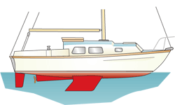 | 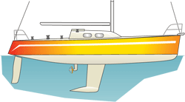

You are here: Sailboat Cruising > Sailboat Design > GZ Curves

Sailboat Design Categories, STIX and Dynamic Stability
Just what are these design categories? In the UK and other EC countries, all pleasure boats must be marked as complying with one of four design categories as set out by the Recreational Craft Directive (RCD).
Similarly all boats built in the US – or anywhere else – for export to Europe, must be certified as complying with one of these design categories.
These four categories A, B, C and D
- A ~ Ocean;
- B ~ Offshore;
- C ~ Inshore;
- D ~ Sheltered Waters.
are described primarily by the wave and wind conditions likely to be encountered and the circumstances under which such a boat might be used.

Design Category A ~ 'OCEAN'
Designed for extended voyages where conditions may exceed winds of Beaufort F8 and significant wave heights of 4m and above, and for which vessels must be largely self-sufficient.

Design Category B ~ 'OFFSHORE'
Designed for offshore voyages where conditions up to, and including winds of wind force 8 and significant wave heights up to, and including 4m may be experienced.

Design Category C ~ 'INSHORE'
Designed for sailing in coastal waters, large bays, estuaries, lakes and rivers where conditions up to and wind force 6 and significant wave heights up to, and including 2m may be experienced.

Design Category D ~ 'SHELTERED WATERS'
Designed for sailing on small lakes, rivers and canals where conditions up to and wind F4 and significant wave heights up to, and including 0.5m may be experienced.
This Rival 38 was built long before the Recreational Craft Directive came into being, but there's no doubt as to her sea-keeping qualities.
In allocating a boat to one of the four categories, the boat's displacement and the Angle of Vanishing Stability (AVS) as indicated on its Gz Curve, play a major part.
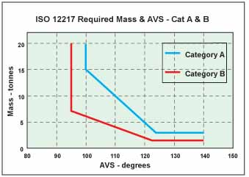
Category A boat limits are a minimum mass of 3.0 tonnes and an AVS greater than [130 - (2 x mass)]º but always equal to or greater than 100º.
Category B boat limits are a minimum mass of 1.5 tonnes and an AVS greater than [130 - (5 x mass)]º but always equal to or greater than 95º.
A Category A boat needs to be to the right of and above the blue line and a Category B boat to the right and above the red line.
But it's not just static stability considerations alone that are taken into account when establishing a sailboat's category - which is where STIX comes in...

ISO 12217, STIX and Dynamic Stability
The International Standards Organisation (ISO) address Small Craft Stability and Buoyancy Assessment and Categorisation under ISO 12217, and similarly use both AVS and mass in dealing with the static stability of monohull ballasted sailing yachts, but take into account a number of other issues in addressing the dynamic issue.
STIX (STability IndeX), a numerical index which scores a boats stability on a scale of 1 to 100, is a function of a number of safety and stability related features, ie:
- length on deck;
- ability to withstand a capsize by considering the area under the Gz curve;
- recovery from inversion by considering AVS and mass;
- recovery from knockdown by overcoming water in the sails;
- displacement/length ratio giving credit for a heavy displacement for a given length;
- beam/displacement factor recognizing problems associated with topside flare and excessive beam;
- wind moment representing the risk of flooding due to a gust
the risk of down-flooding in a broach or knockdown.
STIX scores generally fall in the range 5 to 50 and are applied in addition to the above limits on mass and AVS, ie:
- Category A boats: equal to or greater than 32, and
- Category B boats: equal to or greater than 23.
Since June 1998 all new recreational boats sold in the European Community have been required by law to have undergone a stability assessment with the preferred method being the application of ISO 12217.
This means that all but a very few new monohull ballasted sailing boats sold in the EU will have had a GZ/RM curve generated, their displacement and AVS determined and a STIX calculated.

Hull Drag and Wavemaking Resistance
Any boat underway will experience hull drag, defined as the net force opposing forward movement due to the pressure and shear forces acting on the surface of the hull. It's a function of underwater shape and skin friction.
Clearly a rectangular box section would create more drag than a lozenge shape of similar size. Skin friction is created by surface roughness, and at low speeds is the major hull drag component - as much as 65% at an Speed/Length ratio of 1.0, reducing to about 10% at an Speed/Length ratio of 1.5.
And clearly the more 'skin', or wetted area, the greater the total frictional resistance. This is brutally driven home to the heavy-displacement chaps at anti-fouling time, when find they have a lot more scrubbing to do than their light-displacement colleagues and need to dig deeper into their pockets for the required quantity of paint.
But it's not just the marine flora and fauna that create hull drag. Pitted anti-fouling and protruding skin fittings all conspire to slow us up. Each protrusion disturbs lamina flow and creates a turbulent volume of water, rapidly changing its velocity and pressure and spinning off eddies and vortices.
Nature doesn't like pressure difference, even less a vacuum, and always seeks to level things out. The energy required to re-establish laminar flow downstream of the protrusion is drawn from the forward momentum of the boat, which slows down as a consequence.
Incidentally, we sailors should be very grateful that nature exhibits the same tendency in the atmosphere, as without it there'd be no wind.

Wave Making Resistance and Hull Drag
Not to be confused with the resistance experienced when punching through wind blown waves, this is the energy loss due to the wave making characteristics of the boat itself.
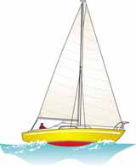
As a boat moves ahead, the water is parted to allow the hull to move through it.
A transverse bow wave forms at the forward end of the hull and a similar wave is created at the stern.
The back of the bow wave forms a trough, and then a second wave that moves aft as speed increases. Eventually, that second wave will have moved right aft where it combines and reinforces the stern wave.
At this point, the boat is said to have reached 'hull speed' and for many this is as quick as it can ever be expected to sail.
Now, with the bow is supported by the bow wave and the stern by the stern wave, the resistance to greater speed is significantly increased. And it's not difficult to see why. If the stern wave was to move further aft, the stern would drop into the trough.
To go any quicker the boat would have to climb over the bow wave - an uphill struggle in every sense and this occurs at an Speed/Length Ratio of 1.34.
The hull speed on any non-planing vessel can be found by transposing the S/L Ratio formula to:
Hull speed (knots) = waterline length (in feet) x 1.34
For example:~
Waterline Length  20 feet  25 feet  30 feet  35 feet  40 feet  45 feet  50 feet | Max Hull Speed  6.0 knots  6.7 knots  7.3 knots  7.9 knots  8.5 knots  9.0 knots  9.5 knots

Planing Hulls
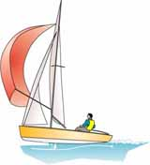
So, predictably, the longer the waterline, the greater the hull speed.
But clearly some boats can exceed hull speed since, if this were a limiting factor, a Laser 470 dinghy shouldn't be able to exceed 3.5knots - which of course they do in spades.
So how do they manage to avoid the limitations of hull drag and wavemaking resistance? It's all about power; sail area in a yacht and horsepower in a motorboat.
We sailboat cruisers can experience this heady sensation in our inflatable tenders. Leaving the dock we gradually wind back the throttle until we're cheerfully chugging along at hull speed.
A further twist of the throttle gets us to a bow up, stern down attitude, but we go no faster and use more fuel.
If the outboard motor is powerful enough, another twist of the throttle will level the boat out as the bow wave travels under the hull releasing us to zip across the water at a clip - with hull drag a thing of the past.
Now we can reduce power to something just above that needed to maintain hull speed and still stay on the plane. This happy state of affairs comes to and end when the throttle is closed, the boat slows; the bow wave catches us up, slops over the transom, and soaks the groceries.
Some cruising boats are capable of exceeding hull speed, and a most desirable ability it is too in my view. Provided, that is, the other desirable sailboat attributes aren't too compromised as a result.
Hull speed can only be achieved if the boat carries sufficient sail area to develop the requisite power, and this is more for a heavy displacement boat than it is for one of lighter displacement.
Read more about hull drag, sail area and displacement...

Boat Displacement and Sail Area
What it Means to a Sailboat's Performance
Boat displacement is defined as the volume of water displaced by a boat afloat, and sail area is the total area of the boat's working sails.
Like speed, displacement doesn't mean much unless compared to waterline length,so you need to take a look at the Displacement/Length Ratio to compare the relative heaviness of boats no matter what their size.
Similarly, sail area doesn't tell you much about a boat's likely performance unless compared to its displacement, which is why we have the Sail Area/Displacement Ratio.
Let's take a look at both of these displacement related ratios in turn...

The Displacement/Length Ratio
The formula for calculating the Displacement/Length Ratio is:
D/(0.01L)³, where...
- D is the boat displacement in tons (1 ton = 2,240lb), and
- L is the waterline length in feet.
An ultra-light racing yacht may have a D/L Ratio of 80 or so, a light cruiser/racer would be around 140, a moderate displacement cruiser be around 230, a heavy displacement boat will be around 320 while a Colin Archer type super- heavy displacement cruiser may boast a D/L ratio of 400+.

Displacement/Length Categories:
Under 90 - Ultralight;
90 to 180 - Light;
180 to 270 - Moderate;
270 to 360 - Heavy;
360 and over - Ultraheavy;
As immersed volume and displacement are proportional, a heavy displacement yacht will have to heave aside a greater mass of water than its light displacement cousin.
Or put another way, the lower D/L Ratio vessel will have a lower resistance to forward motion than the higher D/L ratio vessel, and will be quicker as a result.
That's a longwinded way of saying that the greater the mass, the greater the power required to shift it.
That power is of course derived from the force of the wind acting upon the sails, and the greater the sail area the greater the power produced for a given wind strength.

A Few Examples...
Ultra-Heavy. A Nicholson 32 Mk10, L/D Ratio 394
Heavy. A Pacific Seacraft 37, L/D Ratio 334
Moderate. A Jeanneau 'Sun Odyssey' 47, D/L Ratio 217
Light. A Wasa 30, D/L Ratio 91

The Sail Area/Displacement Ratio
The formula for calculating the Sail Area/Displacement Ratio is:
SA/(DISPL)^{0.67}, where...
- SA is sail area in square feet, and
- DISPL is boat displacement in cubic feet
Clearly then, performance is a function of both power and weight, or sail area and displacement.
Sail Area/Displacement ratios range from around 14 for a lightly canvassed motor-sailor to 20 or so for an ocean racer.

Calculating Sail Area

Mainsail Area
Calculating the area of the mainsail is simple. After all, it's just a right-angled triangle so:~
Area = (Base x Height)/2 = (Foot x Luff)/2
OK, it won't be spot on if the sail has some roach, but it'll be near enough. Having said that, for a fully-battened, heavily roached sail you could add 10 to 15% to be more accurate.

Foresail Area
The foresail would be just as easy if it exactly fitted the fore-triangle but usually the sail will be high-cut or will overlap the mast - or both.
So the calculation becomes:~
Sail Area = (luff perpendicular x luff)/2
For more on this subject, take a look at Understanding Sail Dimensions...

A Final Word on Boat Displacement etc...
So to summarize, the criteria associated with good performance under sail are:
- Boat Displacement: the lower the better, as the power requirement is directly proportional to displacement. Provided, of course, that light displacement doesn't come at the cost of structural integrity;
- Waterline length: the longer the better, as wavemaking resistance is inversely proportional to waterline length;
- Wetted area: the less the better, particularly in areas where light airs prevail, as hull drag is directly proportional to wetted area;
- Sail area: the more the better, within reason, as power production is directly proportional to sail area. Having to reef early is much less frustrating than wishing you had an extra metre or so on the mast when the wind falls away.
- For real 'Get Up and Go' a sailboat will have a low Displacement/Length ratio and ahigh Sail Area/Displacement Ratio.
But performance in an offshore cruising sailboat isn't just about speed. Whilst, as part of the deal for getting their hands on the silverware, a racing crew will cheerfully accept the high degree of attentiveness needed to keep a twitchy racing machine on her feet, a cruising sailor most definitely won't.
For us, a degree of speed will be readily sacrificed for a boat that's easy on the helm, and which rewards its crew with a gentler motion and more comfortable ride.
And whilst talking of comfort, Ted Brewer's 'Comfort Ratio' has much to to with Boat Displacement.

Hullspeed and the
Speed/Length Ratio
So what gives one boat better hullspeed than another? This question was pondered long and hard by William Froude (1810 to 1869), a British engineer who had a special fascination with the sea and ships.
Funded by the Admiralty, who were clearly very keen to get some answers to this question, he built a tank testing facility at Torquay, where he experimented with various model hull forms.
As an early expert in model analysis he was well acquainted with the 'law of mechanical similitude', which demonstrates among other things that there are few linear relationships in hull design.
So just what is the answer?
Let's take a look...

Hullspeed and the Matchbox Analogy

Consider your hull as a matchbox - not wonderfully efficient hydrodynamically, but stick with it for a moment.
Dissatisfied with the constraints of matchbox living, you decide to double its size. You add another matchbox ahead to double its length, two alongside to double its beam and four on top to double its draft.
Now wetted area has increased by four, volume and displacement by eight and stability - as the product of its mass and acceleration - has increased sixteenfold.
So by doubling a hull's dimensions, wetted area is squared, displacement is cubed and stability increases by the power of four.
With this knowledge and that gained by carefully measuring applied force and resultant movement, Froude was able to both calculate and demonstrate that a relationship existed between hull speed and waterline length - that relationship being known and described in the metric world as 'Froude Numbers'.

The Speed/Length Ratio
However, most of us more accustomed to units of feet and knots are probably more familiar with the Froude Number's close relation - the Speed/Length Ratio.

The Speed/Length Ratio
S/L Ratio = hullspeed (in knots) divided by the square root of the waterline length (in feet)
This discovery enabled Froude to compare the performance of boats of different length. For example a 25ft sailboat moving at 5 knots would have the same S/L Ratio at a 100ft patrol boat steaming along at 10knots, and consequently both would develop the same resistance per ton of displacement at those speeds.
For Froude's models, having no rig above the waterline to create windage, this resistance was caused by two principal factors; hull drag and wave making resistance.

Maximum Hull Speed
Maximum hull speed (in knots) = 1.34 x the square root of the waterline length (in feet)
Waterline Length  20 feet  25 feet  30 feet  35 feet  40 feet  45 feet  50 feet | Max Hull Speed  6.0 knots  6.7 knots  7.3 knots  7.9 knots  8.5 knots  9.0 knots  9.5 knots
These figures relate to a boat in displacement mode. If sufficient power can be applied to overcome hull drag and enable the boat to plane, then other criteria will affect ultimate hullspeed.

Understanding the
Prismatic Coefficient
So, what exactly is the Prismatic Coefficient (or Block Coefficient as it's also known) and why do sailboat designers get so involved with it?
Well, hull drag and wave-making resistance isn't only a function of length and surface area; the shapes of the immersed fore and aft hull sections have an influence upon it too.
What is actually crucial is the rate of change of the cross-sectional areas of the hull.
A boat whose hull changes slowly will slip through the water easier and generate less wavemaking resistance than a hull with a rapid rate of change.
This is where the prismatic coefficient comes in; it's a measure of how quickly the cross-sectional area changes, or in sailing parlance, of how full or fine the ends are.
The coefficient is defined as 'the ratio of the immersed volume to the volume of a prism with its length equal to the waterline length and cross-sectional area equal to the maximum cross-sectional area' and is quantified as:~

Prismatic Coefficient (Cp) = V/A
Where:
V is the immersed volume of the hull in cubic feet
A is the maximum cross-sectional area in square feet.
L is the waterline length in feet.

The Cp thus indicates the longitudinal distribution of the underwater volume of a yacht's hull.
- A low (fine) Cp indicates a hull with fine ends.
- A large (full) Cp indicates a hull with relatively full ends.
But it doesn't end there...
The American Admiral David W Taylor discovered while working on warship design during the 1st World War that, for every speed/length ratio, there's an optimum Cp, as follows:
S/L Ratio  1.0 and below  1.1  1.2  1,3  1.4  1.5  1.6  1.7  1.8 and above | Cp  .525 (fine)  .54  .58  .62  .64  .66  .68  .69  .70 (full)
So for a displacement boat sailing at its maximum Speed/Length Ratio of 1.34, the optimum Cp is 0.63. But in light conditions most boats won't achieve anything like their hull speed, and so would be punished in these conditions by a Cp optimized for hull speed.
And herein lays the designer's dilemma, as his creation will sometimes be nudging along gently in light airs and at others blasting along at hull speed or beyond. Knowledge of the predominating conditions in the area that the boat is to be sailed will help him select the Cp.
It's something of a black art, based on technical knowledge and empirical guesswork - and having made his decision, he's likely to keep it very close to his chest.
For more on Cp and other design ratios, take a look at this article by Sponberg Yacht Design Inc.

MODERN SAILBOAT DESIGN: Form Stability
Category: Boats & Gear
Created: Friday, 22 March 2013 20:51
Written by Charles Doane
inShare
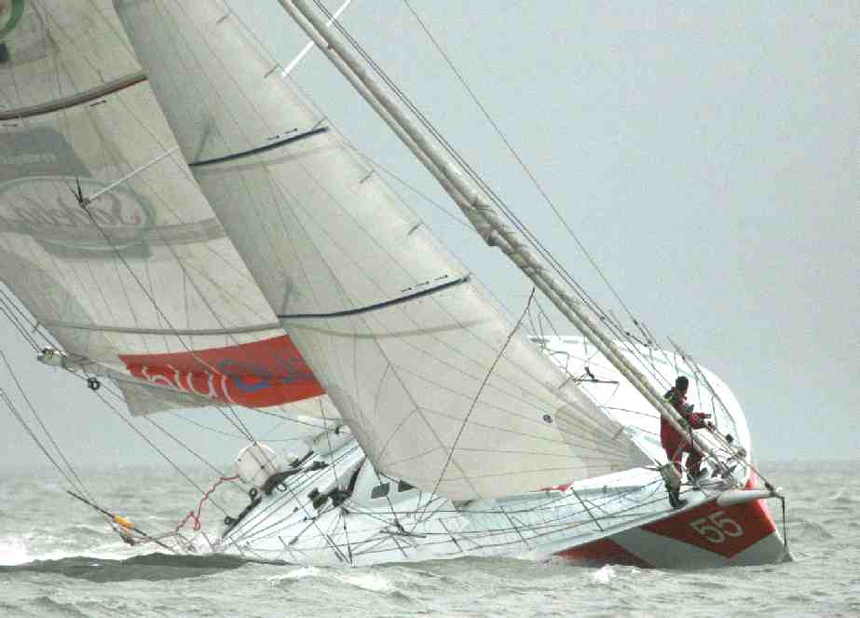
Stability, fundamentally, is what prevents a boat from being turned over and capsized. Whether you are a cruiser or a racer, it is a desirable characteristic. A boat's shape, particularly its transverse hull form, has an enormous impact on how stable it is. This so-called "form stability" is one of the primary reasons you should be interested in the shape of a boat's hull.
The basic principle is self-evident: an object that is wide and flat is harder to overturn than one that is narrow and round. With this in mind, you can usually see at a glance what hull shapes have the greatest form stability. Wide hulls are inherently more stable than narrow ones; given two hulls of equal width, the one with less deadrise and a flatter bottom is more stable than one with more deadrise and a rounder bottom.
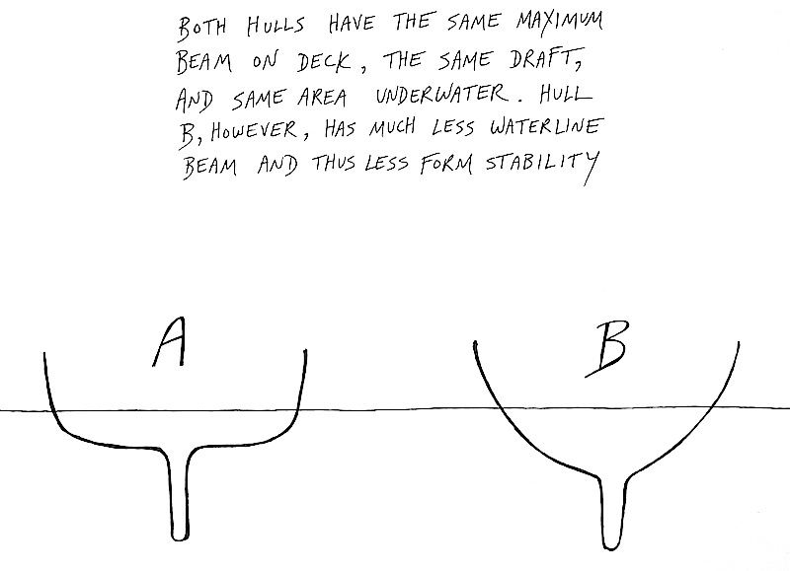
The controlling dimension, when considering width, is always waterline beam. Do not jump to conclusions based on a boat's published maximum beam, as boats with the same maximum beam can easily have very different waterline beams. Another important factor is how a boat's beam is distributed along the length of its hull. A hull that carries more waterline beam into its bow and stern sections--that is, a hull with a larger waterplane--has more form stability than a hull with a wide midsection and narrow ends. The classic example of the latter are the IOR boats that dominated racing during the 1970s. Because the IOR rating rule favored beamy boats but measured beam only in the midsection, designers thought they could have their cake and eat it, too. By making their boats fat in the middle they could gain a rating advantage; by pinching the ends they could reduce displacement and wetted surface area. Such hulls, however, as demonstrated during the 1979 Fastnet Race, are often not very stable.
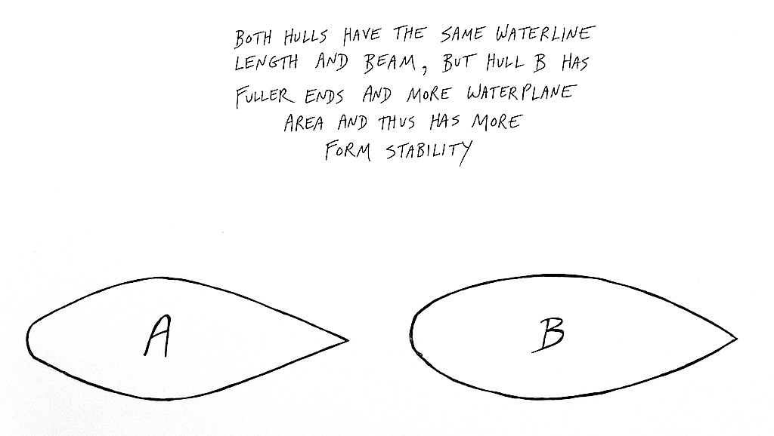
Form stability is an important component of what is termed initial stability, which refers to a boat's ability to immediately resist heeling when pressure is applied to its sails. A boat with lots of initial stability is said to be stiff; one with little initial stability is tender. Stiffness is a desirable feature, as a boat never sails as well when it's heeled way over on its ear. The keel's effective area and draft and its capacity for generating lift are reduced, as are the effective height and area of the sail plan (by about 10 percent, for example, when a boat is heeled to an angle of 25 degrees). A stiff boat that stays more upright not only retains more keel and rig efficiency, it can also stand up to a larger sail plan in the first place. In many cases, particularly if a boat is light, this negates any loss of performance caused by an increase in beam and wetted surface area.
Stiff boats with good form stability in one sense are more comfortable, especially for novice sailors, than boats that heel easily. In another sense, however, they can be very uncomfortable. Though they are rolled to less severe angles, they snap back from those lesser angles more quickly and abruptly than boats with less form stability that are rolled to greater angles. The resulting motion can seem jerky and violent, and this is reflected in a boat's motion-comfort ratio. This quick motion, combined with the tendency of a flat-bottomed boat to pound in a steep head sea, may lead some to conclude that there can be such a thing as too much form stability.
The most important thing to remember about form stability is that it does not translate into ultimate stability. A sailboat's hull form can help it resist heeling up to a point, but past that point all bets are off. A boat that depends too much on form stability to stay upright will be capable of supporting an enormous sail plan in moderate conditions, but when caught in a sudden squall with all its sail up, it can be laid over and capsized very quickly.
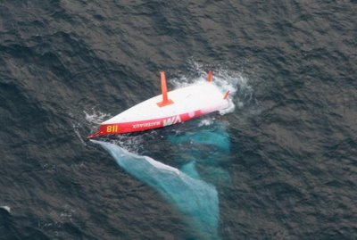
Capsized Open 60s can potentially be as stable upside down as they are right-side up. These days boats most undergo a righting test before competing
In a worst-case scenario, after a hull like this has capsized, its form stability may even help keep it inverted. Fans of singlehanded ocean racing will recall a dramatic series of Open 60 capsizes in the mid- to late-1990s. These extremely wide, flat monohulls, designed to surf at high speeds off the wind in the Southern Ocean, stayed upside down after being flipped over in spite of the very deep (or tall, as the case may be) ballast keels attached to their bottoms.
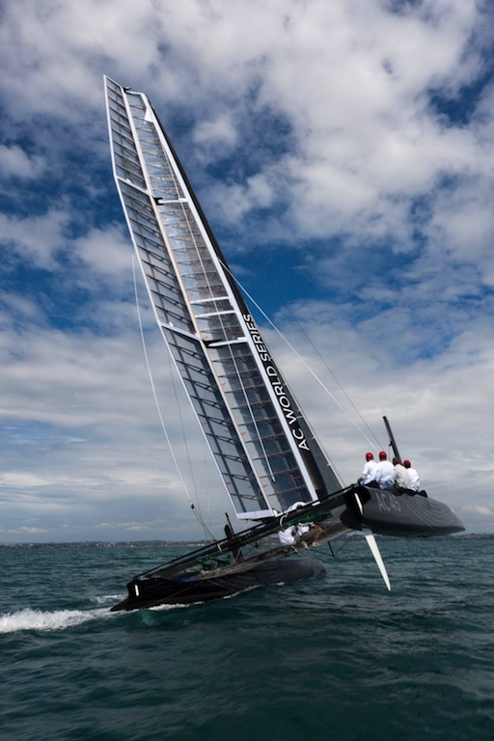
The ultimate in form stability
Multihulls, of course, rely entirely on form stability to stay upright. They are extremely stiff, and it takes an enormous amount of energy to heel them to any appreciable degree. Once pushed to the limit, however, they must flip over and must remain flipped over until an even greater amount of energy arrives to right them. Monohull cruisers, of course, point to this as the Achilles heel of the multihull. Multihull cruisers respond by noting that in a worst-case scenario their boats at least will still be floating (albeit upside down) while the monohull sailor's craft will be sitting (albeit somewhat upright) at the bottom of the sea.

